Image | 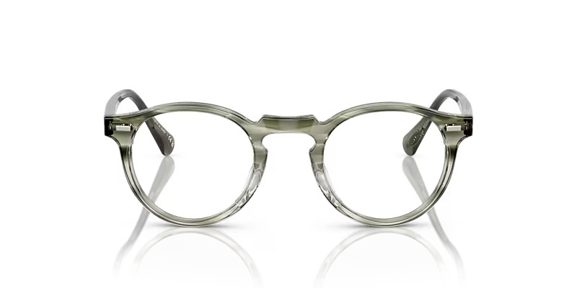
Brand | DIOR
Model Name | GREGOR Y PECK
Price | RS 1800
PRODUCT DETAILS

